CIRCUIT DIAGRAM :

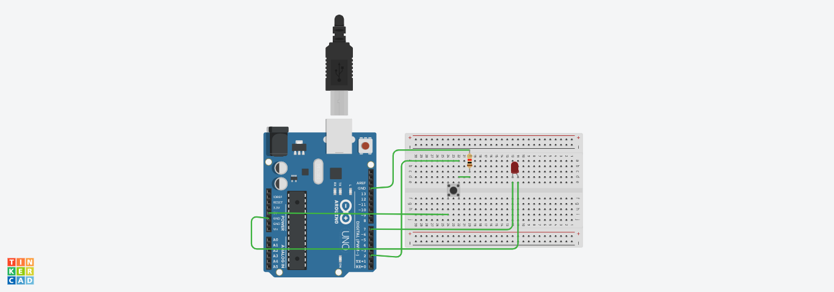

THEORY

CONCEPT USED:

Here we use push button which can be used in door bell and LED which glows ON when we push the push button otherwise it remain switched off. We may also use some sound producing equipment which produces sound on pushing the button.

LEARNING AND OBSERVATION:

1. The range of transmission is fairly large and hence it is suitable for large homes
2. It does not require any Bluetooth enabled phone or any other Bluetooth device
3. We observe that LED turns ON when we push the button

PROBLEMS AND TROUBLESHOOTING:

1. Both transmitter and receiver parts of the circuit must be always turned ON that is there should always be a power supply
2. It requires regular maintainence
3. Its line of sight range is less

PRECAUTIONS:

1. The circuit should not be broken it should be properly closed
2. The bell should ring as long as we keep the button pressed

LEARNING OUTCOMES:

1. When we press the button it triggers a relay which pulls back the latch on the door.
2. We learn how to make door bell system using push button.